**HIGH VELOCITY INDUSTRIAL FANS:**

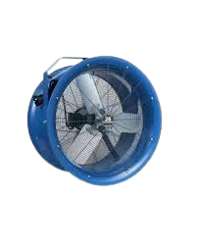

**Price: 22,500.00**

The High Velocity Industrial Fan is a powerful ventilation solution, engineered to provide intense airflow and rapid air circulation in demanding industrial environments. With its high-speed motor and aerodynamic design, this fan delivers a concentrated blast of air, effectively cooling large areas, improving air quality, and increasing productivity. Its rugged construction, adjustable speed settings, and durable components ensure reliable operation in harsh industrial settings, making it an ideal choice for factories, warehouses, and manufacturing facilities.

**Key features of high velocity industrial fans include:**

* **Powerful Airflow**: Provides strong, concentrated airflow for large spaces.
* **Durable Construction**: Built with robust materials to withstand harsh industrial environments.
* **Adjustable Speeds**: Customizable airflow intensity for varying needs.
* **Energy Efficient**: Optimized to move air effectively with less energy consumption.
* **Wide Coverage**: Designed to circulate air over large areas.
* **Portable Design**: Easy to move and reposition for flexible use.
* **Heavy-Duty Motors**: Engineered for continuous, high-performance operation.